Compund interest Questions

But first......

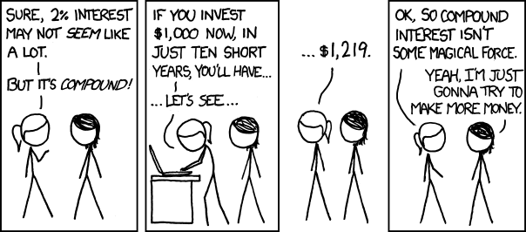

OK, now find the compound interest on:

1. £200 for 2 years at 10% p.a.

2. £300 for 2 years at 12% p.a.

3. £400 for 3 years at 8% p.a.

4. £650 for 3 years at 9% p.a.

5. £520 for 2 years at 13% p.a.

6. £690 for 2 years at 14% p.a.

7. £624 for 3 years at 12% p.a.

8. A house is bought for £40000 and appreciates at 10% each year. What will it be worth in 2 years' time?

9. A postage stamp increases in value by 15p each year. If it is bought for £50, what will it be worth in 3 years’ time?

10. A motorcycle bought for £1500 depreciates in value by 10% each year. Find its value after 3 years

11. A motor car bought for £20 000 depreciates in any one year by 20% of its value at the beginning of that year. Find its value after 2 years.